## **Analysis** [ONE-THREE pages]: Convert the supplied software specification to a list of User Stories (non-ICT technical language). Present the list as a bullet point list or a table.

* Start the app
* Show welcome message
* Get the users name
* Show main menu
* User start a new Game
* Show how to play the game
* exit the app
* Get the number of players from the user
* Select a dealer randomly
* Show Next Player
* Deal 8 cards to each player
* Show the deck
* Show a sub menu
* User play a card
* User draw a card from the deck
* Show the dealt 8 cards to the user

## **Testing** [TWO-TEN pages]: Set up a testing workflow, and illustrate it with your software running screenshots. Use this section to demonstrate your working software to your marking instructor. And/or this section will be used by your marking instructor to test your software solution.

Start the app, show welcome message, Get the users name:

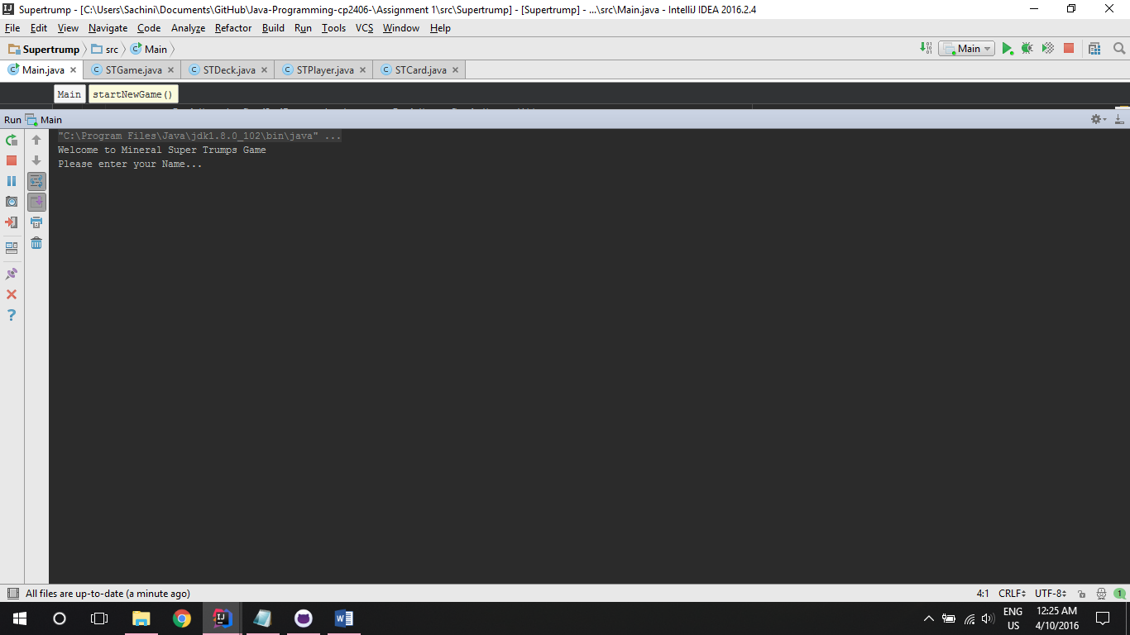

Show main menu, User start a new Game, Get the number of players from the user:

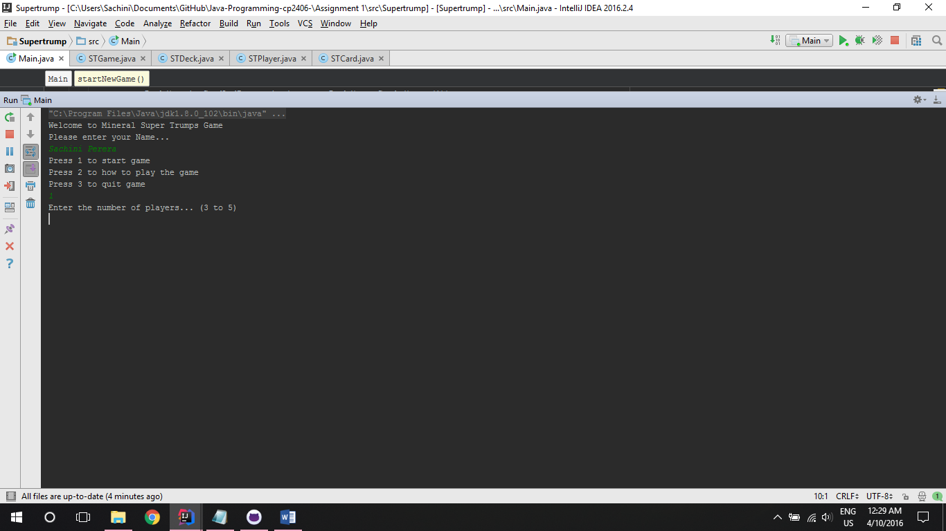

User start a new Game, select a dealer randomly, show next player, Show the deck:

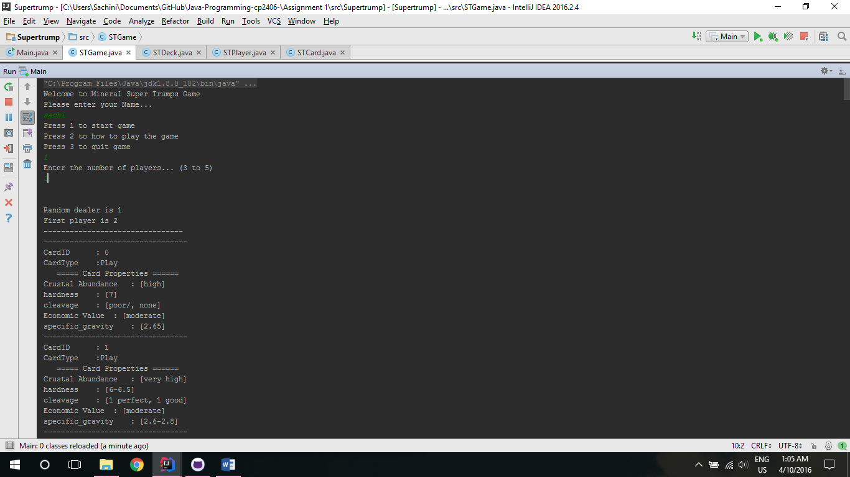

Show main menu, show how to play the game:

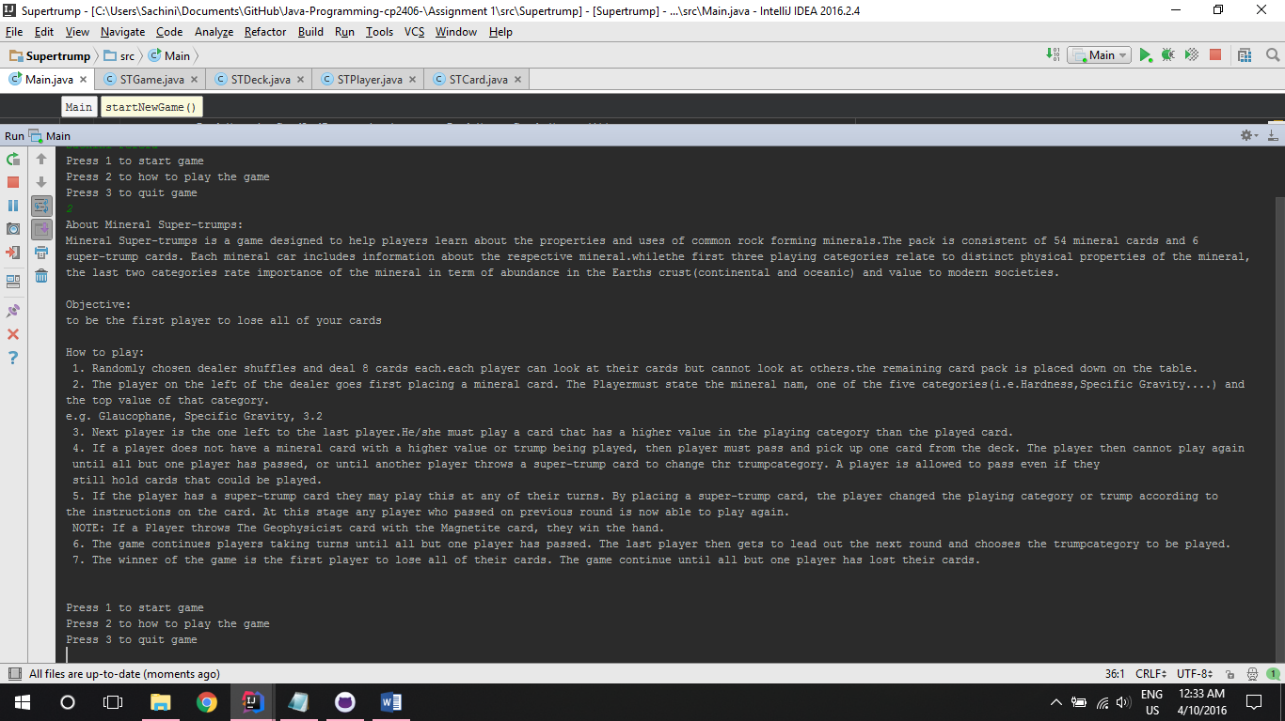

Show a sub menu, deal 8 cards to each player, Show the dealt 8 cards to the user:

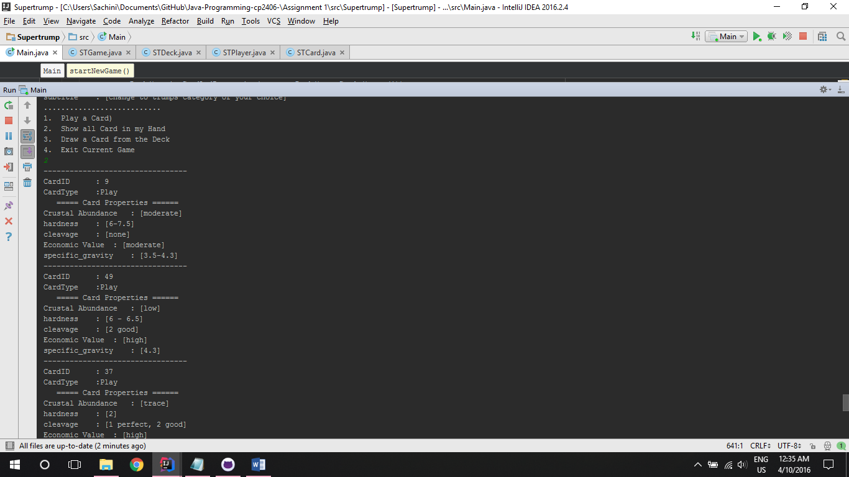

Exit the app:

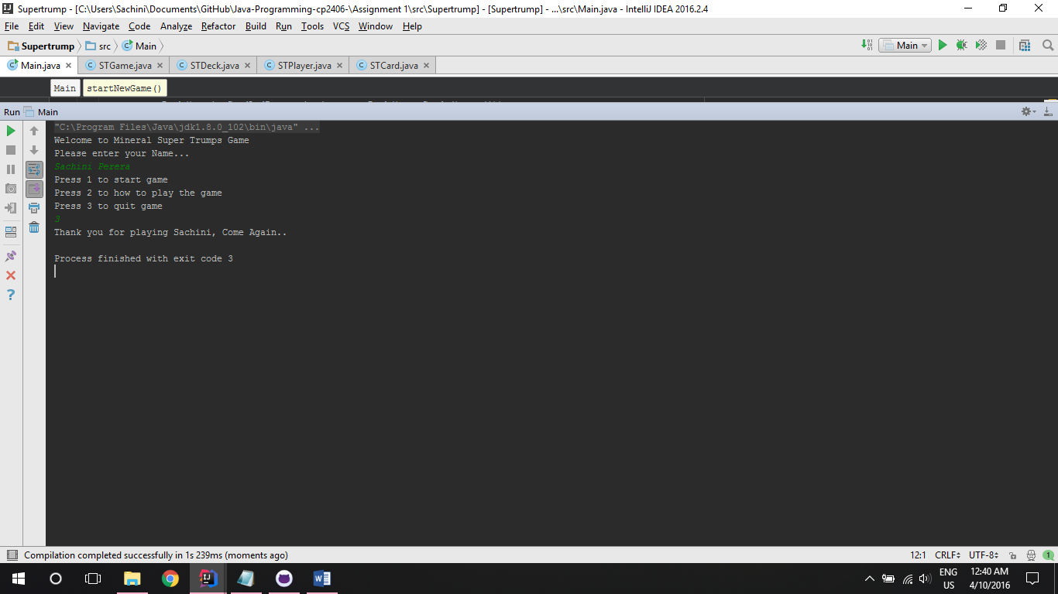

## **GitHub** [ONE-THREE page]: Supply a link to your github repository. Share your repo with your marking instructor. Screenshot (or set up a table) of all significant commits to your repo. You must have regular (5 or more each week) commits. Multiple commits per day are acceptable and encouraged. Make sure you add meaningful commit messages.

Link to the github: <https://github.com/sachiR/Java-Programming-cp2406-/tree/master/Assignment%201/src/Supertrump>